Tokyo University of Agriculture and Technology
Katsuhide Fujita lab.
Shogo Matsushita(s198680w@st.go.tuat.ac.jp)

Experimental Instruction

Use these instructions if you want to refer to the operation during negotiations. Since the contents of the following are almost the same as those on the top page of the experiment, you can read either of them.

Please read the instructions below. Pay special attention to the bold or red sections! The underlines correspond to the areas highlighted in the image.

Overview:

You are about to engage in a series of negotiation games with a partner. The objective is to decide how to divide a set of items. If you can agree with your partner, you'll receive the points allocated on your side when you agreed. You will be playing 3 games.

The first of 3 games consist of 4 items: record crates, antique lamps, Art Deco paintings, and cuckoo clocks. Later games may have different items, and they may be worth more or less! Pay close attention.

In the first game, you get 4 points for each box of records, 3 points for each of the paintings, 2 points for each of the lamps, and only 1 point for each cuckoo clock. This means that the records are worth the most to you!

Your opponent may want the same items you do, or they may not. Talking to your partner can help reveal what items they may want.

About the Game Board:

Below is a picture of the game board. The chat log is on the right, and a picture of your partner on the left. In the bottom half, there is a trade table and buttons. Near your partner's picture, you may see tips appear to help guide you! In the game, you can send messages and questions to your opponent.

You can also move items around on the game board, and send offers. Everything you do will appear in the chat log on the right side of the screen so you can look it over.

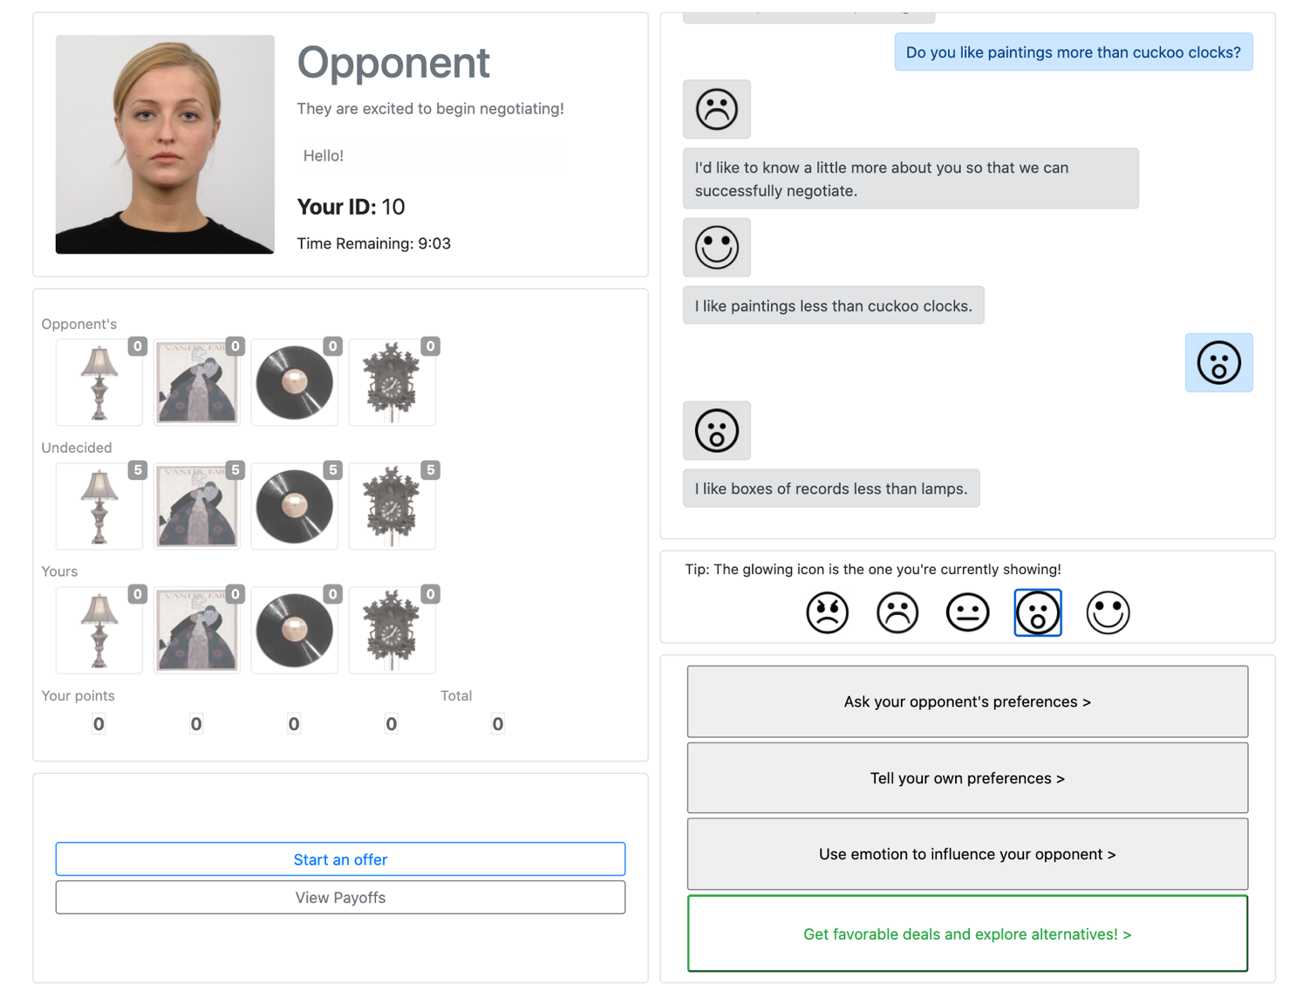

About the Trade Table:

Below is the trade table.With the trade table you are able to send offers to your partner. It will start grayed out. Click "Start an Offer" to enable it.

You can click any item to pick it up, then click again to place it. For example, you can click one of the lamps in the middle and then click it to your side. You can click multiple times for more items.

Nothing sends until you click "Send your Offer".
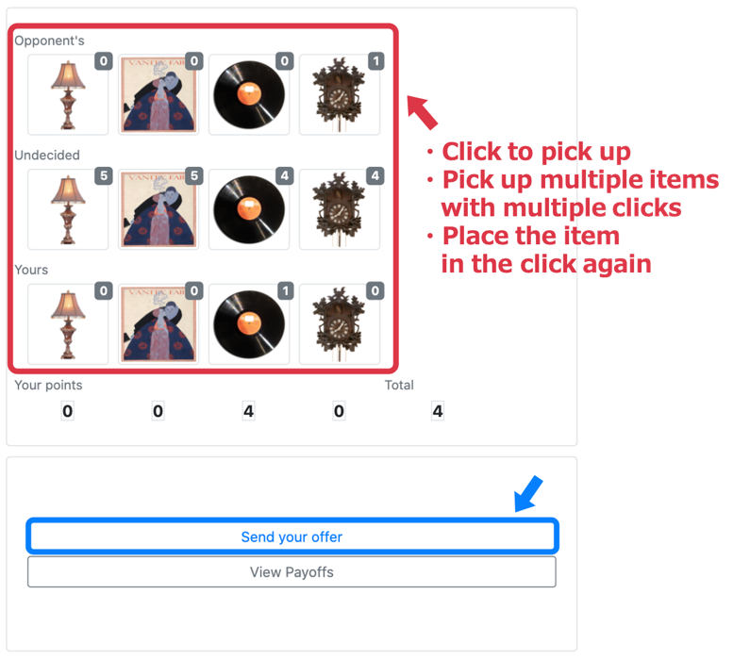
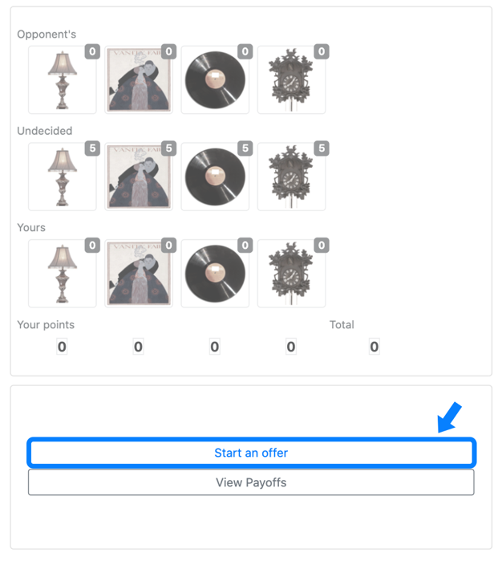

You can also accept or reject PARTIAL offers that your partner sends you as shown in the figure on the left below. These offers aren't binding, but those are helpful in building towards a full offer.
Pressing "Formal Accept" is only possible if ALL items are either on your side or your partner's. If you both agree, the game is finished! Formal Accept is possible when there are no undecided items, as shown in the figure on the right below.
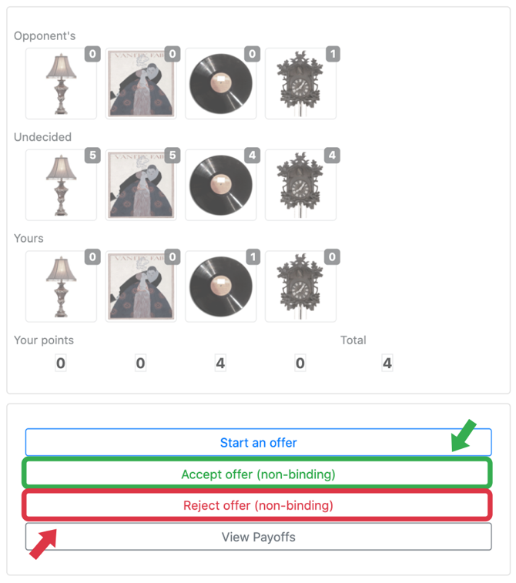
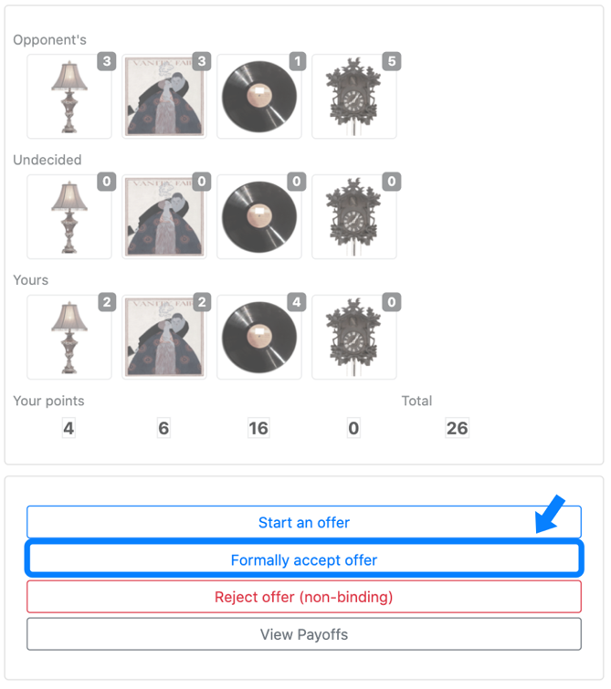

About Emoticons and Avatars:

The buttons you see below can be used to send emoticons in chat! The blinking emoticon is representing your current emotional state. Use it to communicate how you feel about the negotiation!


Depending on how you feel about your opponent's messages or offers, there's a possibility that they may also change their behavior towards you. Knowing the partner's emotions is also important in negotiations. So be proactive in expressing your emotions!

You will be assigned an avatar that will be visible to your partner. Your avatar will change facial expressions when you send an emoticon.

You will be able to see your opponent's avatar across from the chat box. Their avatar's facial expression will also change when they send emoticons. Below is an example of what your avatar could look like.



About Sending Messages:

You can send a message using the button at the bottom right of the screen. Sending messages lets them know how you feel about the negotiations and their offers. Therefore, the sending of messages is an important element in facilitating negotiations. Take advantage of it! You can send the following types of messages to your partner.

- Asking your partner's preferences
- Expressing your preferences
- Reacting to their behavior
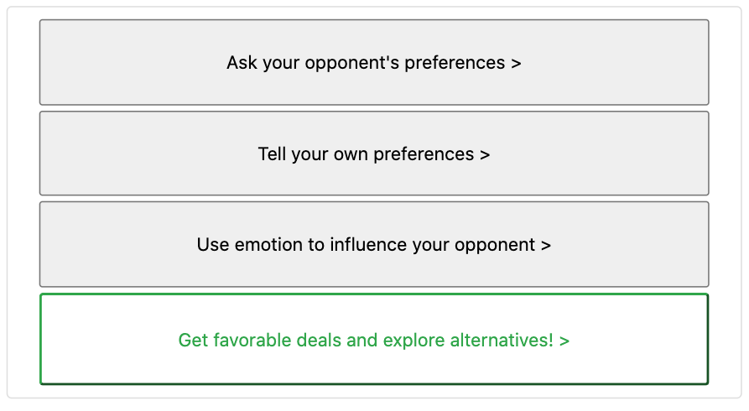
- Making even better agreement

About Expressing and Asking Preferences:

Below you can find an image of the preference menu. During the negotiation you can express your own preferences for items and ask your opponent specific questions about their preferences.

Telling your opponent your preferences or asking to their preferences can have a positive outcome for both parties.

Clicking either of the first two buttons on the right side will let you express your preferences for items.

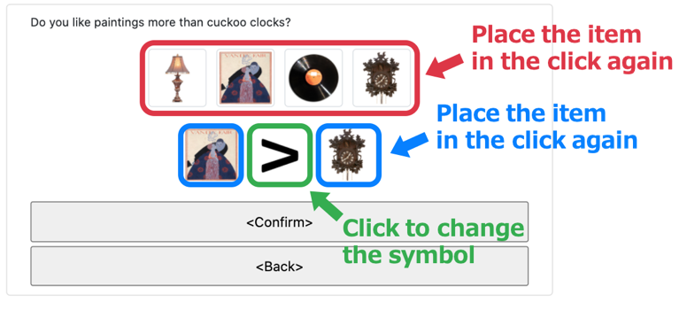
Just click the item you want to talk about once, then click again in one of the boxes. Here, you can see that you're about to ask that your opponent like "paintings" "more than" "cuckoo clocks". You can also click the "more than" symbol to turn it into different options, like "equal" or "best".

About Sending Friendly/Unfriendly/Neutral Messages:

You can tell your partner how you feel by sending each message. There are positive, negative and neutral messages. You can send these messages by clicking the third button from the top on the right side of the game board.

Many messages convey your feelings in the moment to them, but some of these messages may prompt them to take certain actions. There are messages that request them to send an offer, respectively, as follows.

- Friendly options: Would you please make an offer?
- Unfriendly options: What wrong with you? Hurry up and make an offer!
There are also messages that threaten the opponent.
- Friendly options: I'm sorry but I think I may walk away.
- Unfriendly options: You making me want to walk away from this!
The following message also asks them to tell you about them preferences.
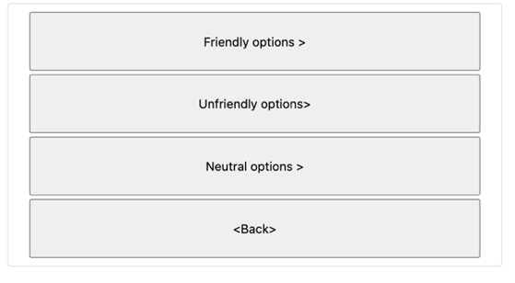
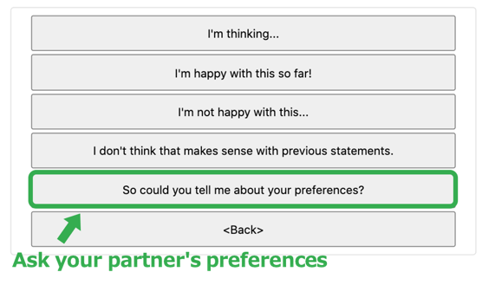
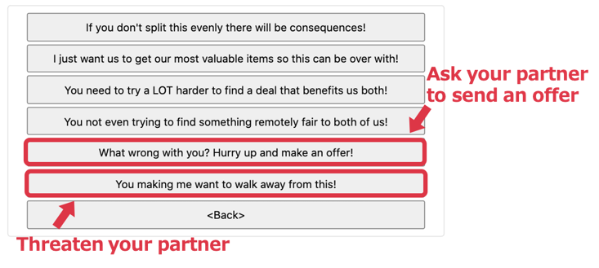
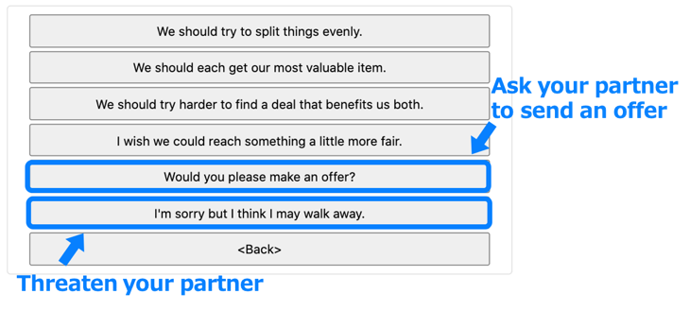
- Neutral options: So could you tell me about your preferences?

About Sending Other Messages:

The green button in the lower right of the screen allows you to exchange information with your partner, including information that is more directly related to the outcome of the negotiation. You can use the following messages to convey the points you already have at the start of the negotiation (called BATNA) to them. You can change what you tell them by moving the slider.

- My bottom line is...
If you want to know their BATNA, please send the following message.
- So could you tell me what's your bottom line?
Use the message below to ask them to send you a good offer.
- Would you please send a good deal in exchange for a favor?
If they send you a good offer by the above message, give them return the favor and they will be happy too! Let them know that you will repay them with the following message.
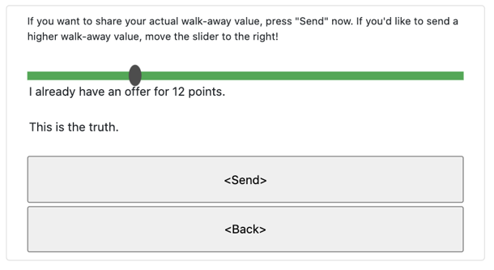
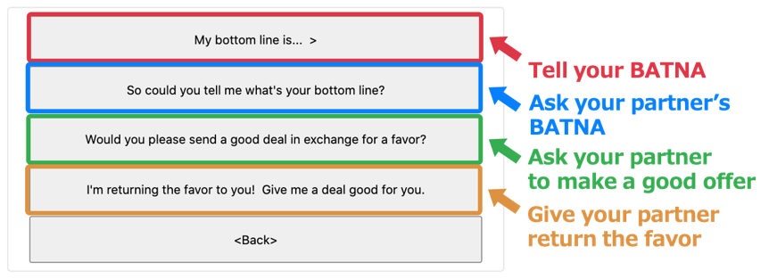
- I'm returning the favor to you! Give me a deal good for you.

Some Final Important Notes:

The items and your preferences WILL CHANGE for each game if you are playing multiple games, so make sure to click the "View Payoffs" button at the bottom left of the screen if you need a reminder what you're looking for. A pop-up will appear, as shown below. You can see the value you get with each item and your BATNA. Negotiate to get a better value than BATNA!

The ONLY way to finish the game is to press "Formal Accept" and have your partner also press it, or for time to run out. Pressing "Accept (non-binding)" will not work.

When negotiation time is run out, you get the points you have as BATNA. Since BATNA is considerably less value, try to reach a "Formal Accept" in time as much as possible!

You don't necessarily have to tell the truth about preferences or BATNA. However, be aware that lying can be difficult to negotiate.

Your partner may lie as well.

In rare cases, images may not be displayed, the connection may be broken, or your ID may not be displayed due to wrong screen size. Please reload the page in that case.

We recommend that you finish the three negotiations at once. However, if you want to interrupt the negotiations, such as when it is difficult to do so continuously, close the browser tab and end the negotiations. To resume negotiations, enter your ID in the form at the top of the page.

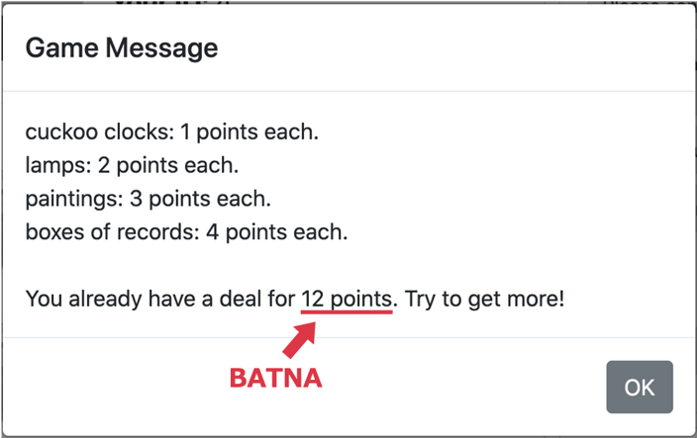
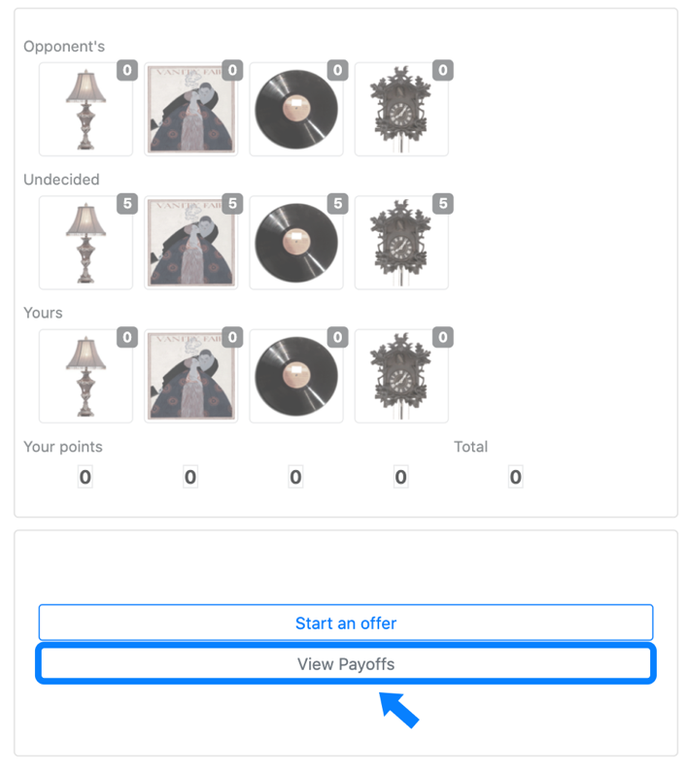
If you have any trouble or questions about negotiations or experiments, please contact s198680w@st.go.tuat.ac.jp.

However, we highly recommend to check the operation here first. This is only a confirmation of the operation, not an action from your partner.

Be sure to confirm that the ID displayed at the top of the screen is yours when you start negotiating. It is recommended to check this manual while negotiating, so that you can check the operation while playing.

